Press Release

rapidFLIM – redefining the standards for dynamic FLIM imaging

PicoQuant releases application note describing a novel fluorescence lifetime imaging method with fast image acquisition

Berlin (Germany), 29 August 2016 – A recent publication by PicoQuant lays out the basics of rapidFLIM, a novel, dynamic Fluorescence Lifetime Imaging (FLIM) method, along with practical applications. The rapidFLIM approach allows image acquisition with several frames per second and thus opens the way for the study of dynamic processes in living cells or other materials through fast fluorescence lifetime imaging. It is ideally suited for observing fast processes, like protein interaction or chemical interactions, following highly mobile species including live cells, moving organelles, or nanoparticles, as well as investigate Förster Resonance Energy Transfer (FRET) dynamics. Depending on sample brightness and image size, rapidFLIM allows acquiring more than 10 to 15 frames per second.
The method exploits recent hardware developments such as TCSPC modules with ultra short dead times and appropriate hybrid photomultiplier detector assemblies enabling significantly higher detection count rates. These improved hardware components make it possible to achieve much better photon statistics in significantly shorter time spans while being able to perform FLIM imaging for fast processes in a precise manner along with high optical resolution. By using a pattern matching analysis integrated into PicoQuants SymPhoTime 64 software, excellent FLIM contrast can be obtained without need for classic decay data fitting.
The rapidFLIM method can be integrated into many existing confocal laser scanning microscopes from major manufacturers such as Nikon, Olympus, or Zeiss through LSM upgrade kits offered by PicoQuant. The required kits include a TimeHarp 260 NANO with negligible dead time and a matched hybrid detector from the PMA Hybrid Series, along with a choice of pulsed laser sources and the system software SymPhoTime 64.

About PicoQuant
PicoQuant is a research and development company in the field of optoelectronics. The company was founded in 1996 and is based in the science and technology park Berlin-Adlershof, Germany. The company is a worldwide leader in the field of single photon counting applications. The product line includes pulsed diode lasers and LEDs, photon counting instrumentation, fluorescence lifetime spectrometers and time-resolved confocal microscopes. PicoQuant employs currently around 60 people. Since April 2008 Sales and Support in North America is handled by PicoQuant Photonics North America Inc.

Attachment
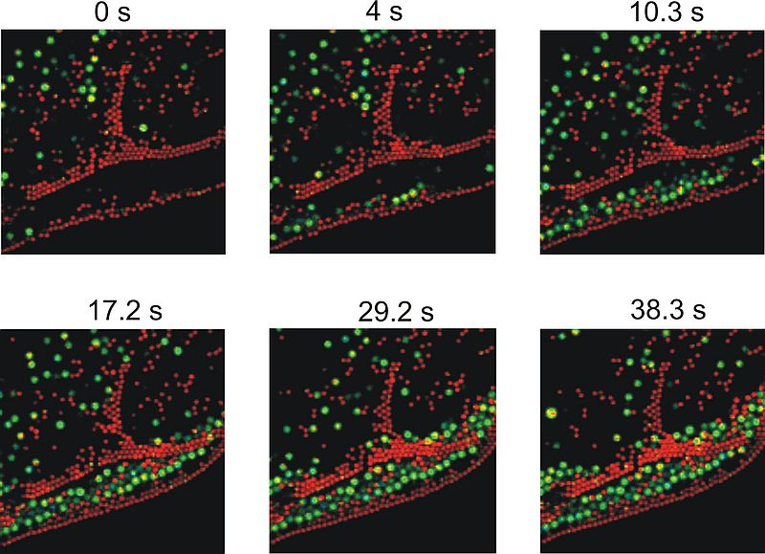
Caption: Diffusion of dye-labeled beads in water, imaged with three frames per second. A selection of frames from a video is shown.

Contact
André Devaux
Technical Writer
Tel.: +49-30-6392-6936
mkt@picoquant.com
www.picoquant.com

